Name of Event / Activity |  | Event Date: | Time:
Person conducting assessment: |  | Position:
Location of Activity or Event: |  | Internal External (tick )
Activity Co-ordinators/Leaders:
Describe the activity or event:
First Aid Officers if required:

Questions to consider when assessing the activity or event: (Note the following is not an exhaustive list)
- Is this activity occuring on the Organisation’s grounds or in an external location not under your control?
- Is this activity being run by external contractors? If yes, obtained copies of current public liability insurance certificates and or qualifications, and safe operating procedures?
- How many persons will be involved in this activity or event at the one time? Over 500 people requires declaration to Insurers.
- Will children be involved, do persons supervising children have a current Working With Children/Vulnerable Persons Check/Clearance, Blue Card or equivalent?
- Is there anything on the site or used in the activity or event that has the potential to cause harm to a person?
- Are amusement devices included in the activity e.g. jumping castles, climbing equipment, compressor, machinery etc? Have maintenance records been provided and reviewed? Is equipment or machinery isolated from access?
- Will food be supplied for sale or consumption? Consider Food Safety measures?
- Is a traffic plan required where pedestrians and traffic will interact?
- Consider the security of the event, adequate lighting, handling of money, storage of valuables?
- Electrical safety, use residual current devices or safety switches where possible, check condition of leads, and keep leads away from water and walkways.
11. Are there clearly outlined rules and instructions on how the event will operate, and have supervisors or leaders been briefed on the activity and their roles to ensure safe practice?

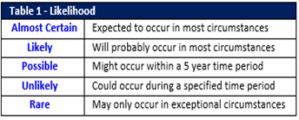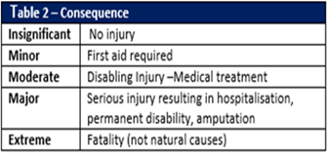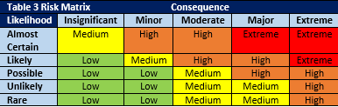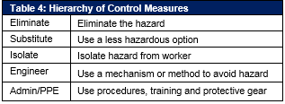

Low – Medium = Safe to proceed | High = Unsafe, controls must be reviewed / signed off  Activity may have conditions applying. | Extreme = Unsafe do not attempt activity

Step 1  List identified hazards and risks | Step 2  Likelihood (Table 1) + Consequence (Table 2)  = Risk level (Table 3) | Step 3  Using the Hierarchy of Control Measures (Table 4) identify suitable control measures to eliminate or minimise the level of risk | Has the risk level reduced?
Hazard or Risk | Risk Rating | Control Measures/Actions to be Taken | Y/N

PERMISSION TO PROCEED

Review Completed By: _________________________________________________________________________________________

Role of the Reviewer: ___________________________________________________________

Date Completed:_______________________________________________________________

Outcome of Risk Assessment ( apply the legend above and tick )
Safe |  | Unsafe (requires review of controls) |  | Unsafe (activity is not to be attempted)

SIGN-OFF BY AUTHORISED DIOCESAN OFFICER

Sign-off to confirm activity and controls are acceptable and able to occur
Manager in Charge |  | Date:

Other notes:

