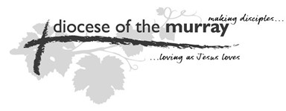
Diocese of The Murray

APPLICATION FOR NEW ACCOUNT

Parish …………………….……………………………………
I. ……………………………………………………………………………………..
Secretary of the above-named Parish do
HEREBY CERTIFY THAT at a meeting of the Parish Council
duly convened and held
the (date) ………………………………….
the Parish requests that an account be setup by the Diocese of The Murray under the title of:
………………………………………………………………………………………………………
………………………………………………………………………………………………………
Initial Amount $........................................ (Cheque enclosed)
Any Special Conditions
………………………………………………………………………………………………………………………………………………
………………………………………………………………………………………………………………………………………………

Signed ……………………………………………………………………
Parish Secretary

