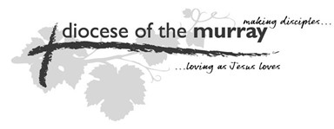
The Diocese of The Murray

THE THIRD SCHEDULE

(Section 8 [2])

I.....................………………............................................................………......…....................
(Name in Full)

of.................................................……………….......................................………….................
(Address in Full including Post Code)

DO HEREBY DECLARE

- That I am a member of The Anglican Church of Australia and that I am a communicant of the said Church:
- That I belong to no other religious denomination:
- That I have received the Holy Communion not less than three times during the preceding twelve months:
- That I am a member of the Parish of ______________________ and no other Parish.
- That I have attained the age of 18 years.
- That I hereby accept the office of lay member of the Synod and any other office to which I may be elected or appointed pursuant to the Constitution and Ordinances and promise to perform the duties thereof honestly, impartially, faithfully and to the best of my judgement and ability and in accordance with and subject to the said Constitution and Ordinances.
- That I agree to comply with the Safe Ministry Requirements within 3 months from date of election.

Signature...........................…….............… Witness..................………….................

Date...................................................

